**Project description**

Gary wants a tool to help him collect data about students' movements in the class. This tool will be used by Gary and let him customize lots of stuff in a classroom. The classroom should be modeled inside the tool. Most of the items in a classroom should be modelable in the tool, e.g. chairs, seats, tables etc.

Gary will place students somewhere in the classroom with some identifiable properties about them (like hair color, clothes etc.). The, client will be able to move each student over time. Each movement will be saved and an appropriate report will be generated at the end in a meaningful format.

**User classes and characteristics**

* Instructors in TC 412 and are not required to have any technical background since the system will be easy to use.

**Technical constraints**

* Web based site
* Front end technology utilized

**Use cases**

* Use case: Access from browser(laptop or tablet)

Actor(s): User

Summary: Allow the software to be accessible from a browser and responsive

Priority: High

Pre-Condition: User must be on the website

Post-Condition: The software allows access from this format.

* Use case: Reconfigure Classroom

Actor(s): User

Summary: Allow reconfiguration of the classroom

Priority: High

Pre-Condition: User must be on the website

Post-Condition: The software records changes made by user

* Use case: Save Image(Layout)

Actor(s): User

Summary: Allow user to export layout to image.

Priority: High

Pre-Condition: User must be on the website

Post-Condition: The software exports changes made by user

* Use case: Use symbols to identify students

Actor(s): User

Summary: Allow user to have unique id’s for each student/teacher

Priority: High

Pre-Condition: User must be on the website

Post-Condition: The software identifies each object(student and teacher) uniquely.

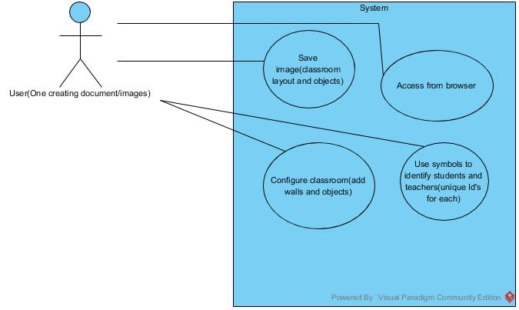

**Functional requirements**

* Change classroom layout

Priority: High

* Save snapshots of class

Priority: High

**Non-functional requirements**

* Access on laptops and tablets

Priority: High

**Assumptions**

* Symbol based ui with moveable and unmoveable parts

Confirmed by Client